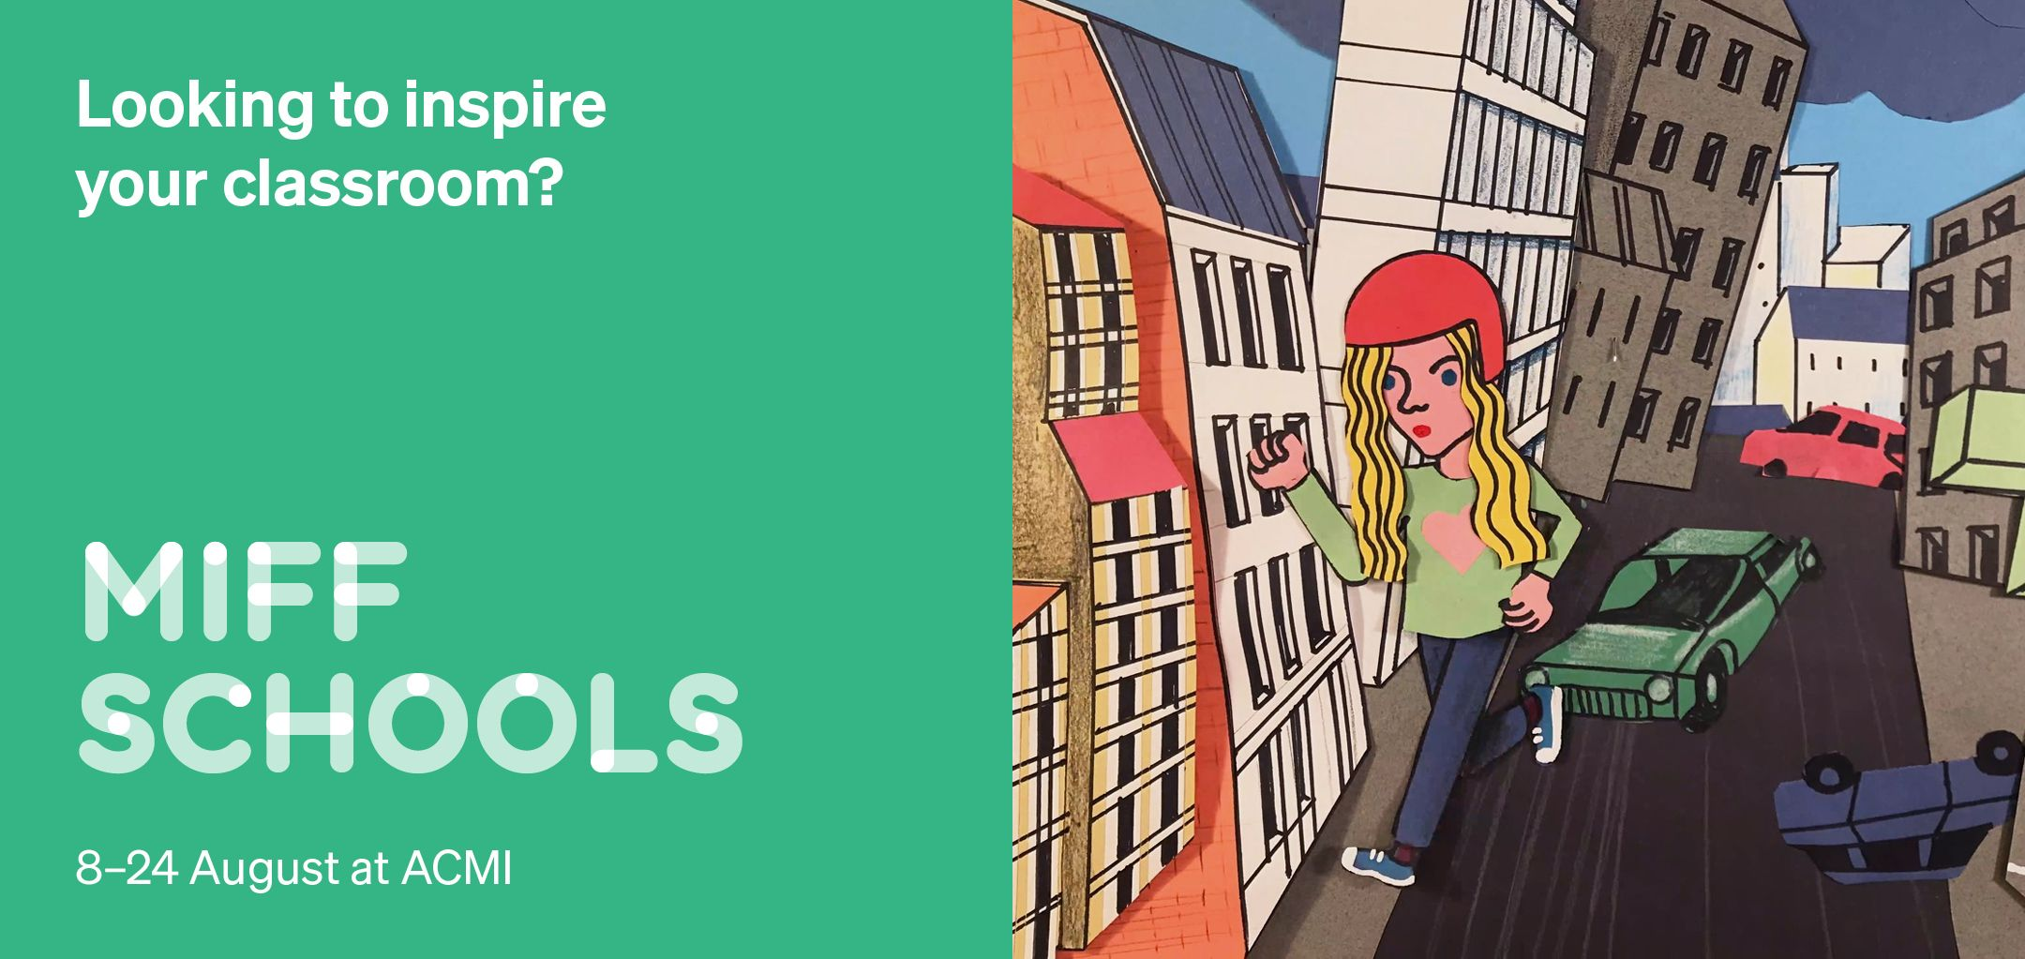
Explore the power of cinema, storytelling, language and culture

A Story About Fire
Dir Li Wenyu (China, 85 mins, 2025, Mandarin with English subtitles)
In this evocative animation based on an ancient Chinese myth, a cowardly monkey musters the courage to discover the secret of all warmth.
Sessions: 12.30pm Wed 13 Aug (ACMI Cinema 1) and 10am Thu 21 Aug (ACMI Cinema 1) _____________________________________________________________________________

Greetings From Mars
Dir Sarah Winkenstette (Germany, 84 min, German with English subtitles)
Recommended for ages 8+

Is there life on Mars? One young lad with autism wants to find out … if he can only conquer four weeks at his grandparents’ place in the country first. Themes include family relationships, working as a team, nerodivergency, coming of age and astronomy.

Sessions: 10am Mon 11 Aug (ACMI Cinema 1) and 10am Wed 20 Aug (ACMI Cinema 1)
_____________________________________________________________________________

Happyend
Dir Neo Sora (Japan, USA, 113 min, Japanese language)
Recommended for ages 12+

In a dystopian urban landscape where technology is used to curb civil liberties and student rights, a diverse group of teenagers struggle to maintain their long-held friendships. Themes include activism, friendship, family obligations, standing up for oneself, loyalty and coming of age.

Sessions: 10am Fri 15 Aug (ACMI Cinema 1) and 12.30pm Thu 21 Aug (ACMI Cinema 1) _____________________________________________________________________________

I Saw a King
Dir Giorgia Farina (Italy, 95 min, Italian language)
Recommended for ages 10+

When an exiled Ethiopian prince is imprisoned at his grand family home, a young daydreamer awakens to the reality of fascist Italy. Themes include war, coming of age, family, friendship and racism.

Sessions: 1:30pm Mon 11 Aug (ACMI Cinema 1) and 11am Tue 19 Aug (ACMI Cinema 1)
_____________________________________________________________________________

Looking for Alibrandi (4K Restoration)
Dir. Kate Woods (Australia, 103 min, English language)
Recommended 15 +

In this award-winning, generation-defining Australian coming-of-age story, Alibrandi’s female-led production team bottled Australia’s millennial zeitgeist as lovingly as a jar of homemade tomato sugo – and in this new 4k anniversary restoration, its magic is fresh for the teenager of every year. Themes include family, relationships, coming of age, identity, mental health and community.

Sessions: 10am Thu 14 Aug (ACMI Cinema 1) and 12.30pm Wed 20 Aug (ACMI Cinema 1)
_____________________________________________________________________________

Maya, Give Me a Title
Dir. Michel Gondry (France, 61 min, French language)
Recommended 8+

Michel Gondry returns to his roots with this wildly creative animated omnibus, assembling surreal two-dimensional adventures to entertain his young daughter. Themes include art, family, imagination and creativity.

Sessions: 10am Wed 13 Aug (ACMI Cinema 1) and 12.30pm Tue 19 Aug (ACMI Cinema 1) Screens with An Urban Allegory
_____________________________________________________________________________

Spreadsheet Champions
Dir. Kristina Kraskov (Australia, 86 min, English, Greek, Spanish, French languages)
Recommended for ages 10+

Six young people from around the globe channel their dreams into a competition with a difference: a test of their elite mastery of Microsoft Excel. Themes include competition, resilience, tenacity, community and family

Sessions: 10am Tue 12 Aug (ACMI Cinema 1) and 12.30pm Fri 22 Aug (ACMI Cinema 1)
_____________________________________________________________________________

Têtes Brûlées
Dir. Maja Ajamia (Belgium, 86 min, French, Arabic, Dutch languages)
Recommended for ages 12+

A young girl wrestles with her Tunisian heritage as she grieves the loss of her beloved adult brother. Themes include: belonging and identity, family, culture, grief, music, dance, social media and friendship

Sessions: 1.30pm Tue 12 Aug (ACMI Cinema 1) and 11am Fri 22 August (ACMI Cinema 1)
_____________________________________________________________________________

